SUNRISE TEACHERS
CALCULATING YOUR CORRECT PAY AMOUNT – September 2018*

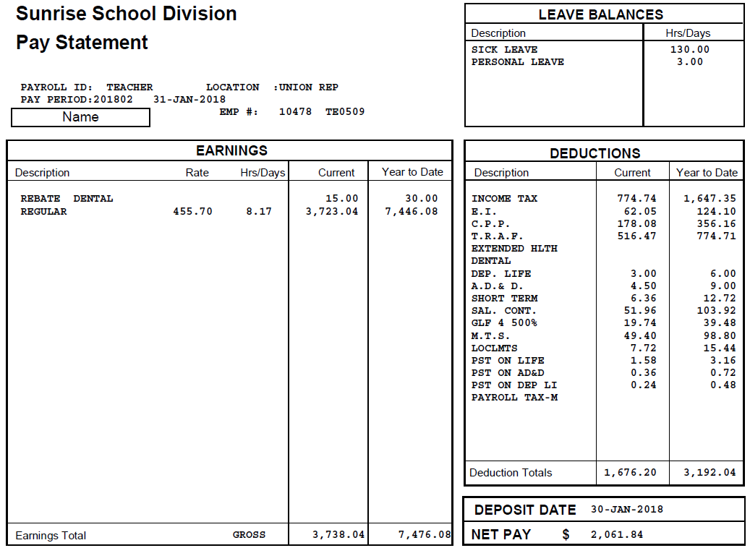
Note: This is the
NET GRID

(2018- 19) |  |  |  |  |  |  | $3,018
Years | Class 1 | Class 2 | Class 3 | Class 4 | Class 5 | Class 6 | Class 7
0 | $47,095 | $55,399 | $63,641 | $55,292 | $59,221 | $63,076 | $66,920
1 |  |  |  | $58,406 | $62,433 | $66,476 | $70,474
2 |  |  |  | $61,520 | $65,643 | $69,867 | $74,035
3 |  |  |  | $64,635 | $68,853 | $73,263 | $77,590
4 |  |  |  | $67,742 | $72,065 | $76,662 | $81,149
5 |  |  |  | $70,863 | $75,276 | $80,056 | $84,704
6 |  |  |  | $73,973 | $78,489 | $83,450 | $88,263
7 |  |  |  | $77,086 | $81,694 | $86,845 | $91,822
8 |  |  |  | $80,202 | $84,907 | $90,239 | $95,375
9 |  |  |  | $84,519 | $89,329 | $94,848 | $100,143

NOTES: $89,328.96

1. This example applies ONLY if you have a 1.0 FTE contract and subscribe to Dental and Extended Health Benefits. *

2. If you have less than a 1.0 FTE, multiply the Salary amount that applies to your Grid Placement and Salary Class, by your FTE. Using the example above – If your FTE is .5, your salary calculation would be .5 X 89,329.00 = 44,664.50. Multiplying your regular pay (from the pay stub) by 24 should confirm this.*

3. If you DO NOT subscribe to the Benefits program, use the GROSS Grid (available on the STA Website) to calculate your correct pay.*

4. * Members returning from a Leave may achieve an inaccurate calculation.

$3,722.04
Regular Pay
1. TO CALCULATE YOUR CORRECT PAY AMOUNT… USE THE NET GRID (Below)
2. MULTIPLY YOUR REGULAR PAY BY 24 PAYS. In this case… $3,722.04 X 24 = $89,328.96
3. COMPARE WITH YOUR YEARS GRID PLACEMENT AND SALARY CLASSIFICATION

